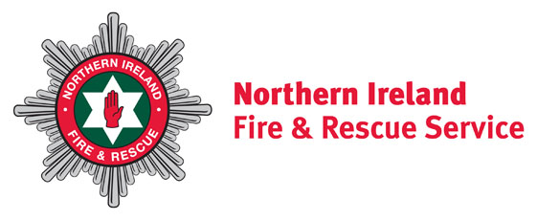
May 2020

Dear Occupier

Northern Ireland Fire & Rescue Service (NIFRS) is committed to keeping people safe and working with the community to STOP accidental fires in the home.

As you may be spending more time at home, it is important that you are aware of fire hazards in your home and that you know what you can do to help protect yourself and your family from accidental fires.

Accidental fires in the home have increased since the beginning of COVID-19 and we want to make sure that our community has all the information they need to make sure they are safe from fire at home. Accidental fires are often caused by cooking, electrics and smoking.

If you have no working smoke alarms, please contact us at the number below and we will agree a time to deliver smoke alarms to your home free of charge. The smoke alarms will be prepared and tested before being placed at your door. At this current time we are unable to enter your home, however we will provide advice on where to place the smoke alarms and will offer a follow up visit at a later date.

If you would like a free Home Fire Safety Check including delivery of a smoke alarm or if you have any concerns about fire risks in your home, please ring us at 028 92 664221 (Mon to Fri, 9-5pm).

More information about fire safety in the home is available on our website www.nifrs.org where you will find lots of additional and useful information.

Our aim is to continue to STOP accidental fires in the home from happening.

*Please still remember - in an emergency dial 999*

Yours sincerely
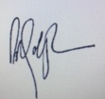

Paddy Gallagher

Headquarters
1 Seymour Street
Lisburn BT27 4SX

T 028 9266 4221

F 028 9267 7402
enquiries@nifrs.org
www.nifrs.org

Chief Fire & Rescue Officer (Interim)

Michael Graham

Assistant Chief Fire & Rescue Officer
Director of Service Delivery

